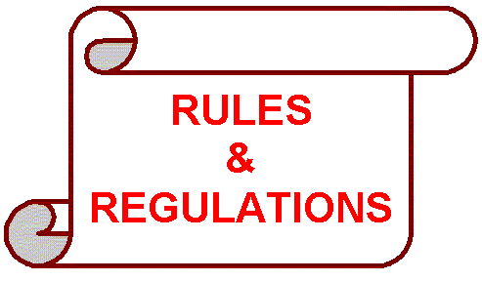
We would like to take this opportunity to remind you of some of the Condominium Rules and Regulations that are frequently over looked. We need your cooperation to ensure our Community remains as a desirable and safe property.
Balcony:
- Cigarettes must be disposed of inside your unit. Throwing cigarette butts off your balcony may result in damage to your fellow neighbors’ furniture, litter their balconies, or cause injury to people below.
- Bicycles are to be stored inside your condominium unit or in the assigned rental storage room, and not outside on your balcony.
- Damp mops are to be used to clean your balcony. By throwing water, you will affect your neighbors below.
- Storage Boxes, as well as coolers and any other items that are not patio furniture, must be kept inside your unit. Umbrellas are also not allowed, as these are potential projectile items during windy conditions.
- Grills of any type are not allowed on balconies by fire code.
Trash:
- Please remember to dispose of your Trash between 8:00 am and 10:00 pm.
- Remind your cleaning personnel to dispose of the trash bags inside the trash chute.
- Disposal of cardboard boxes inside trash room, stairwell and hallways is prohibited.
- Take care that your trash is not leaking when taking it from your unit to the trash chute.
Common Areas:
- Dogs must be leashed in all common area, including hallways.
- Dog waste in common areas (elevators, hallway etc.) is your responsibility. Please make sure to clean after your pet. You may be fined if caught not picking up your pet waste.
- Dogs are only permitted in service elevator.
- Key Fobs must be used at all times.
- No Dogs are allowed in the Front Lobbies/Owners must use the rear entrance and service elevator when accompany their pet.

Your Board of Directors and Management Team thank you for your cooperation in following the rules above, which will protect, and enhance the Community environment for all.

